**Effectiveness of State Policy Actions to Address COVID-19**

**CSP571 Project Report**

**Team Members:**

Kacper Malysa · Mingxi Xia · Roman Sydorchuk · Spencer Sumner · Yurun Liu

**1. Abstract**

The impact of COVID-19 has dramatically altered the daily lives of U.S. citizens. Public policy related to the pandemic can be described as haphazardly implemented and contentious in nature. It seems clear that, given the socioeconomic cost of the pandemic, it is vital to identify the public health policies that produce the best outcomes. A number of data repositories have gathered publicly available information on the pandemic’s outcomes, and the public responses to the disease since the beginning of the crisis. In this project, we used this information to evaluate the effects of different types of policies on COVID metrics such as infection, hospitalization, and deaths over time. Our data allowed us to examine the differences in COVID metrics across different states based on what policies they chose to implement and when they did so. Our ultimate goal was to identify the most effective public health policies for fighting Covid-19. After running our analyses, we found that policies mandating the closure of workplaces and public transportation, along with stay-at-home orders were all associated with decreased confirmed COVID-19 cases and deaths.

**2. Overview**

The COVID-19 pandemic has provoked sweeping responses in public health policies across the globe. Given that the pandemic continues to this day, research into these policies and their effects on health outcomes is still ongoing, however, several prior publications do exist that attempt to quantify these consequences. Some of the earliest research on this subject was conducted by Hsiang et al. [5], who focused on the effects of anti-contagion policies across the countries of China, South Korea, Italy, Iran, France, and the United States. This research concluded that anti-contagion policies generally resulted in significant reductions to COVID growth rates, although the precise effects of these policies differed across populations [5]. In the case of the U.S., the combined effect of implemented COVID policies were associated with a reduction in daily COVID growth rates of 31.61% between March 3rd and April 6th of 2020 [5]. Much of this reduction in COVID growth rate can be attributed to social distancing measures, business closures, and policies focused on home isolation [2,3,5]. Stay at home orders demonstrated some of the most significant results in terms of infection rate, and had remarkably consistent effects across different states [1]. Within the U.S. itself the combined effects of social distancing and shelter-in-place orders were predicted to have prevented as many as 90% of COVID cases in the first two months of the pandemic [2]. This result must be taken with some caution, however, for a number of reasons.

First, these results were obtained via an extrapolation of predicted COVID spread models compared to actual observed growth rates [2]. Second, the precise effect associated with shelter-in-place orders has been observed to vary across different states and across areas with differing population densities [3]. States that had high population densities, and who adopted shelter-in-place orders earlier on in the pandemic appear to have seen a more dramatic reduction in COVID infection rates than less densely populated states who implemented their orders later [3]. One policy that has not been mentioned thus far is the public mandate to wear facial coverings while outside of the home. A review of the literature related to mask use and respiratory diseases found that, while wearing a mask may not directly prevent infection, it does greatly reduce the possibility for an afflicted individual to spread the disease to others [7]. A specific relevant study was carried out in Kansas earlier this year. The legislature of Kansas issued a statewide mask mandate, but made it optional for different state counties to opt-in or opt-out of the mandate [4]. A later review of COVID infection statistics found that counties which had implemented the mask mandate had significantly lower rates of COVID-19 infections compared to counties which had not implemented the mask mandate [4]. Another area in which public policy can be helpful is in limiting the opportunities for infection by the removal of public transportation. A recent case study conducted in China demonstrated that airborne transmission in enclosed spaces, like those provided by public transportation, can easily result in large scale spreading events [6]. Other research conducted among infected populations in China has indicated that the implementation of workplace closures effectively reduces the infection rate, particularly if the return to work is done in a staggered fashion [8]. Based on the reviewed research, we may expect that an analysis of the available COVID-19 data will demonstrate significant relationships involving stay-at-home orders, workplace closings, public transportation, and facial coverings.

While all of these results are encouraging for supporters of public policy initiatives, we must caution that research in this area is still ongoing, and that confounding factors do exist. One such confounding factor is the large-scale adoption of social distancing measures by the public on their own initiative. As noted by Ziedan et al., [9], much of the decline in mobility, economic activity, and social interaction between individuals can be attributed to private decisions made by individuals either before or during the adoption of COVID public health policies. These confounding factors make it all the more important for us to closely examine the available data. The identification of the most effective policies for combating COVID-19 is crucial, both for avoiding wasteful restrictions and for saving lives.

**3. Data Processing**

The process of obtaining, cleaning, sorting, and organizing the data needed for this project was one of the largest portions of it. There were a few iterations and ideas for our dataset that we went through before deciding on the final compilation that was briefly introduced in the previous section. The main problem stemmed from the fact that while there is tons of data available for COVID-19, none of it has everything we needed to answer the questions that this project set out to accomplish. To figure out which policy implemented due to the pandemic has been the most effective, we had to compile data not only about the policies themselves, but also on statistics that we could measure that effectiveness against. The idea for these statistics ranged from obvious choices such as infection and death rates, to more detached ones like testing rates, etc.

The initial source for our data was very uniform, and from the looks of it seemed like a perfect compilation of all those statistics that we’ve mentioned previously. It was the C3 AI COVID-19 Data Lake [10]. As it is described in the description of that data lake, it “uniquely integrates multiple data sources in a unified data model, ready for analysis - not just a list of links or a collection of data sets”. This data source looked promising in saving us hours of data cleaning and sorting processes, and allowing us to jump straight into analysis and modeling. From this, we were able to extract great data on different policies, and statistics, which are both pieces that we needed to complete this project. As an example, the C3 AI COVID-19 Data Lake allowed us to create graphs such as these in an incredibly short amount of time:

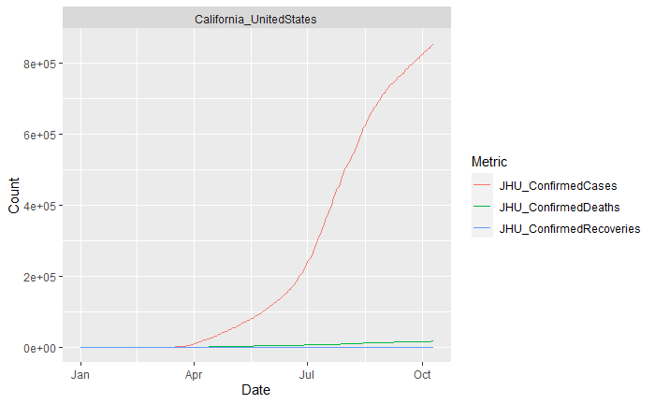

*Figure 1 - Statistics on Confirmed cases, deaths, and recoveries in California form the C3 AI COVID-19 Data Lake*

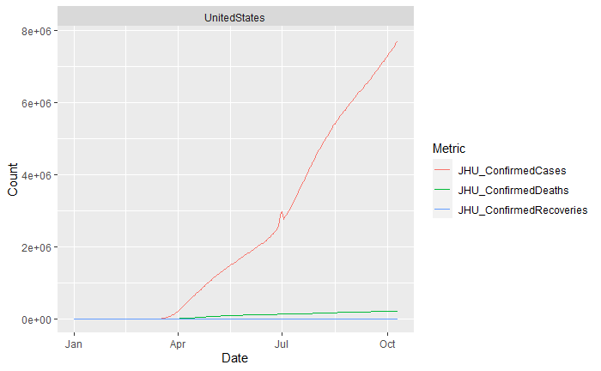

*Figure 2 - Statistics on Confirmed cases, deaths, and recoveries in USA form the C3 AI COVID-19 Data Lake*

While all the data was there, and most of it seemed easy to access, we ran into multiple issues with the API provided. A lot of the statistics and policies that we needed to access were not available on a granular level, and the results were only accessible in very specific formats. For example, we had a difficult time accessing the start dates of different policies and their severity levels on a state level. While the API made it extremely easy to find out what the current policies in place were and when they were implemented, getting the historical data on a satisfying granular level was just not possible, or at least not within the time scope of this project. This led our group to the list of sources that C3 AI COVID-19 Data Lake used for its API, which turned out to be the right step to take.

Since we no longer could obtain both the statistics, and policy data from one source, we decided to look for two separate data sources, and combine them into a final one which we would use for analysis and modeling. For our statistics, we went with the COVID-19 Data Repository by the Center of Systems Science and Engineering (CSSE) at Johns Hopkins University [11]. This dataset had daily reports on the statistics within the United States, and had daily updates starting from 04/12/2020, all the way until the current date. For our final combined dataset, we pulled all the data up to 11/30/2020. Once all the data was pulled and combined, we ended up with 13474 rows of data spread across 18 variables, from which we ended up using the following 6:

* Province_State
* Last_Update
* Confirmed
* Deaths
* Mortality Rate
* Hospitalization Rate

Now that we had tons of data that we could measure our policies against to check whether they were effective or not, the next step was to find a good source for the policies themselves. Initially we went with the Kaiser Family Foundation COVID-19 Data [12], which seemed like a good fit due to its formatting and an easy way to combine it with the John Hopkins University data for statistics. This set has been updated daily since 06/04/2020. After pulling and cleaning up some of the messy data, we ended up with 1916 rows spanning 14 variables, 11 of which we ended up trying to use in our final combined dataset. Those 11 variables were:

* State
* Stay.at.Home.Order
* Mandatory.Quarantine.for.Travelers
* Non.Essential.Business.Closures
* Large.Gatherings.Ban
* School.Closures
* Restaurant.Limits
* Version
* Face.Covering.Requirement
* Status.of.Reopening
* Bar.Closures

Using those two data sources, we were able to start analyzing some of the relationships between input and output variables, and get an idea of what models we might want to use, which will be described in a later section. This combined dataset allowed us to create some initial graphs and visualizations for these relationships, which looked as follows:

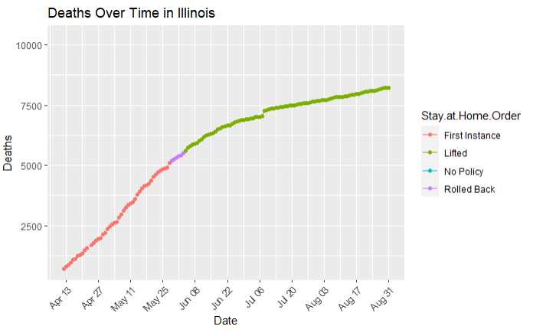

*Figure 3 - Deaths Over Time in Illinois in regards to Stay At Home Order policy*

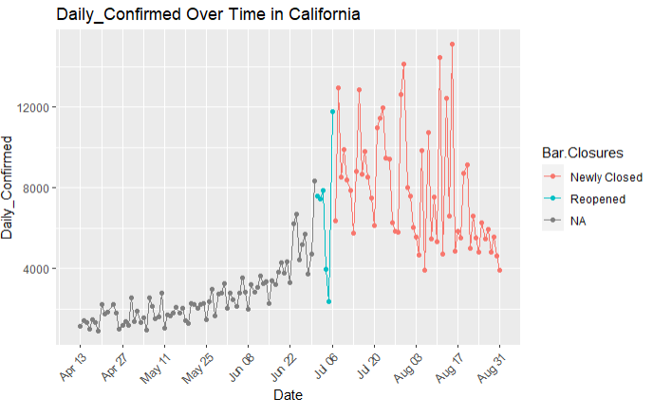

*Figure 4 - Daily Confirmed Cases Over Time in California in regards to Bar Closures policy*

These datasets worked really well together, but unfortunately there were few issues; the two main ones included thinking of a method to group/parse the policy data based on a more simple parameter such as severity, and the lack of data for policies before 06/04/2020. To tackle the first issue, we needed to find a dataset that describes the severity of policies in a more uniform way, instead of it’s own informational strings in a form of notes. We can easily read that bar closures are split into no policy, reopened, and newly closed, but there is no way to compare that data against each other with different policies. Moreover, we were not able to create an automated script/model in R that would process this data nicely. To resolve the second issue, we simply needed a dataset that went at least as far back as the John Hopkins University data. This led us to find our final choice for the policies data: University of Oxford Blavatnik School of Government USA state level Covid-19 Policy Responses dataset [13]**.**

This dataset not only went as far back as 01/01/2020 which is impressive considering the amount of research and backtracking the researchers had to do to pull information before COVID-19 really developed in the United States, but also included information about the same / similar policies to the other dataset, grouped by severity levels listed as integers instead of strings. This dataset has been updated daily, and gave us 17756 rows of data spanning over 30 variables, 12 of which we ended up using to match our previous choice of a dataset in a similar way. After some minor cleanup, the variables we ended up choosing were:

* Province_State
* Version
* C1_School.closing
* C2_Workplace.closing
* C3_Cancel.public.events
* C4_Restrictions.on.gatherings
* C5_Close.public.transport
* C6_Stay.at.home.requirements
* C7_Restrictions.on.internal.movement
* C8_International.travel.controls
* H3_Contact.tracing
* H6_Facial.Coverings

The visualizations created from this dataset work just like the ones from the Kaiser Family Foundation, but we can see how they incorporate the integers instead of strings for severity levels:

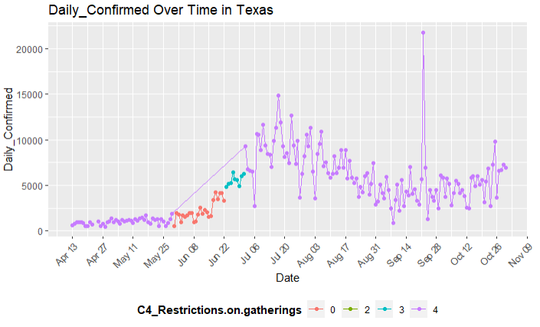

*Figure 5 - Daily Confirmed Over Time in Texas in regards to Restrictions On Gatherings policy*

The University of Oxford data in combination with the John Hopkins University data allowed us to finally create our final combined dataset, which we ended up using for the remainder of the project. This final dataset consisted of 17757 observations, spread across over 62 variables, from which we ended up using all the ones we mentioned before from the statistics, and the policies dataset. Our dataset ranges from 01/01/2020 all the way up to 11/30/2020, but for modelling and analysis purposes we only went back to 04/12/2020 since that’s when our statistics data began. Obviously it would be ideal to find a data source which has this missing early data, but time was limited and getting this final data set all cleaned and combined was a challenge in itself.

Throughout this section we’ve mentioned minor cleanups, but to be more granular about our steps, it’s important to explain some of the methods we used to get this final data set sorted out, outside of the obvious join on state names and dates. First, before joining the datasets we had to remove or decide to ignore certain columns. Since all those pieces of data come from different sources, we had to make sure that we removed any identification columns that those organizations used to keep track of these pieces of data amongst many other ones that they possess. As expected from a dataset this large, there were quite a few NA values to handle. For example, the policies data had NA’s due to some of the policies not being implemented right away for certain states, or ending earlier. We handled this not during the initial cleanup process since that could result in us running into dangerous assumptions regarding our available data, but later on during the modeling process. Doing this through code instead of manual cleaning also speeds up the entire process. The final step was to remove certain rows, the biggest example of that being in regards to the Province_State column, where we had some additional data that described more than just the States that we needed. There were separate rows for data from Virgin Islands and other similar locations, that we ended up omitting in the end due to the focus of our project.

While this entire process of gathering data and cleanup took way longer than anyone on the team anticipated, it was well worth it in the end. The final combined dataset allowed us for quicker and more organized analysis and modeling, and we all had an opportunity to learn a lot about how to process and combine datasets from completely different sources. Now that we have discussed our data in depth, we can talk about how this previously mentioned process of analysis and modeling actually went.

**4. Data Analysis**

Upon obtaining a combined version of the data, we were able to begin exploratory data analysis. As mentioned previously, the data we had of COVID statistics only went back to 04/12/2020, so we could not take a look at a lot of the early on state policies. However, obtaining the new policies data expanded our range all the way until 11/30/2020, resulting in a net increase in the range that we can analyze.

Before taking a look at the data or the visualizations, we thought about how our data might generally look like. Remembering how many states responded to COVID, we expected to see a lot of states starting out with the most severe levels of policy, and tapering off over time until the next spike of new cases.

Our initial exploratory analysis involved looking at plots of particular statistics and policies for different states. For instance, here’s a plot of Daily Confirmed Cases over time in Florida, with the coloring based on the severity of School Closing policy in the state:

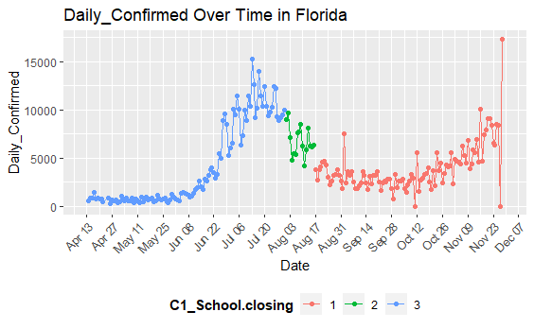

*Figure 6 - Daily Confirmed Cases Over Time in Florida in regards to School Closing policies*

We can see that our earlier conjecture aligned pretty well with this particular set of parameters. The School Closing policy severity started off most severe at level 3 and eventually tapered off right around the beginning of August to levels 2 and 1. Furthermore, from our data, the C1_Notes column tells us exactly what the policy in place is that warrants each severity level. For instance, on August 1st when the severity dropped from 3 to 2, the policy that caused the drop ordered "all schools, including charter schools, to reopen at least five days per week for all students with locally driven decisions whether or not to open or close a school” [14].

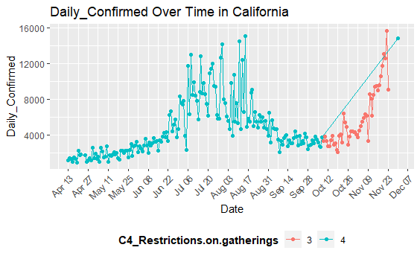

*Figure 7 - Daily Confirmed Cases Over Time in California in regards to Restrictions on Gatherings policies*

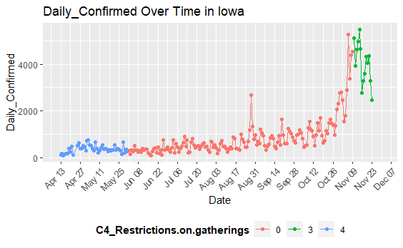

*Figure 8 - Daily Confirmed Cases Over Time in Iowa in regards to Restrictions on Gatherings policies*

Similarly, additional plots in Figure 7 and Figure 8 seen above also exhibit similar behavior of restrictions easing up over time. From Figure 8, we see that the lower severity levels seem to correlate with a bigger rate of change in the Daily Confirmed statistic. However, looking at Figure 7, the case of California suggests that some severe policies might not be as effective in decreasing the rate at which the virus spreads as we see big spikes despite high severity levels. The compilation of all the states when building the model will help us draw a conclusion about the effectiveness of each policy type.

From these visualizations, we decided on creating linear regression models for each state and policy, and for each policy severity. We would then compile the coefficients (slopes) obtained to draw a conclusion on the effectiveness of the policy with respect to a COVID statistic.

Using a function intended for testing, we can further visualize how the models will be formed in relation to the data. In the following plot, we see the data of the plot in Figure 7 (California) for policy severity 3 only with the model fit overlayed:

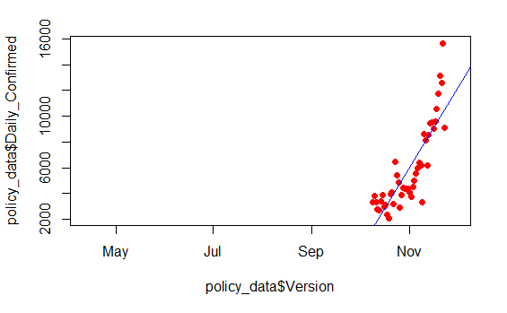

*Figure 9 - Daily Confirmed Cases Over Time in California in regards to Restrictions on Gatherings policy severity level 3, with the model fit overlayed*

We only use linear models as a baseline to be able to compare the coefficients (slopes), despite many of the models warranting a different kind of fit. We handle those cases by taking into account the model’s p-values, which we will discuss in more detail in the next section.

**5. Model Selection and Training**

As mentioned previously, in summary, our approach to modeling for this project was to create linear regression models across varying parameters and combine them for each state to obtain mean coefficient values. But before we could get started with this, we had to make sure we can automate the generation of these models due to the sheer quantity of them. A singular example model would include a state, a statistic, a policy, and the severity of that policy. Our goal was to generate models for each state, statistic, policy, and severity before compiling them together. With 50 different states, 6 statistics, 10 policies, and 0-4 severities for each policy, this required some more cleaning up of the data in order to allow models to be built for any combination of given parameters without any errors.

As mentioned in the Data Processing section, we cut down the data to only include states, and we removed any NA values as we could not make any assumptions about the statistic or policy data for unknown values. Now, as we moved on to the actual model building, we recognized that not all models will be valid. For instance, some models might only be able to use a few observations. To handle cases such as these, we decided to only create models where at least 10 observations are used to ensure the validity of the models.

However, throwing out the models that have fewer than 10 observations does not necessarily guarantee that the remaining models are perfectly fine to be used for analysis. We could still be generating linear models where the fit is just not good enough to facilitate a significant enough result. The following plots highlight prime examples of such cases:

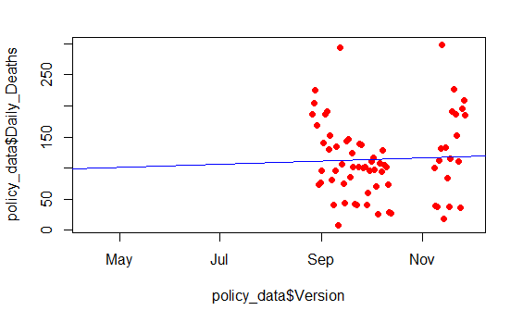

*Figure 10 - Daily Deaths Over Time in Texas in regards to School Closing policy severity level 2, with the model fit overlayed*

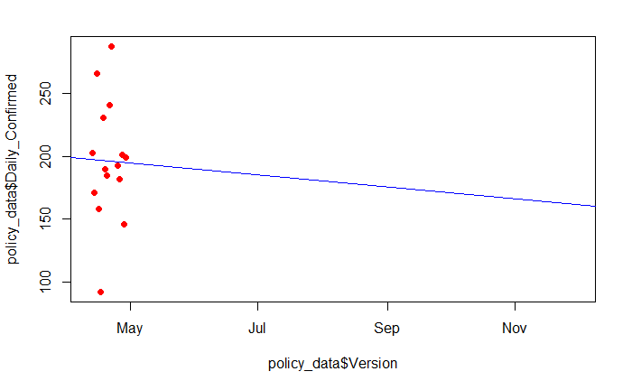

*Figure 11 - Daily Confirmed Cases Over Time in Alabama in regards to Workplace Closing policy severity level 3, with the model fit overlayed*

In both of the figures above, we can see that the model should definitely not be used as it does not provide anything of significance and would most likely result in inconsistencies during the compilation. So, to handle cases like these, we consider the p-values of the models built. In particular, if the |p-value| > 0.05 for a model in question, we remove that model from our list. In the above cases, the p-values were extremely high (~0.8 - 0.95), indicating little to no significance, so these models get removed from our list in the “remove_large_p” function part of our modeling process. This is also our substitute for training/test data. Since our goal is not to generate a model that will predict future data, we simply use the p-value as a measure of validity to each model that we generate.

This removal/cleaning process is clearly documented in the R Console output so that we are aware exactly of what is being removed in case we need to verify results or make any adjustments. The output is formatted in a way that is clearly legible and easy to tell which severity is being removed from which state and the reason why. This way we have a clear list of which policy severities are included after the check for the minimum number of observations required and which models are removed after the check for the maximum p-value allowed.

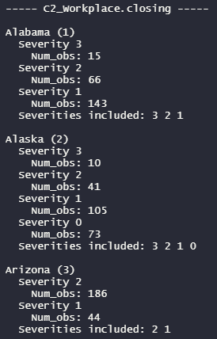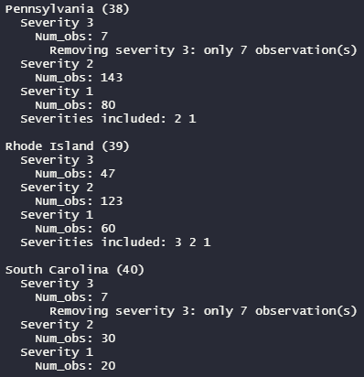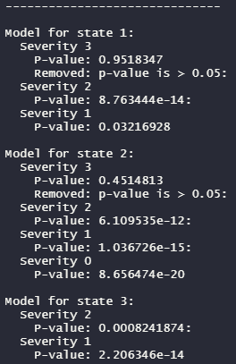

*Figure 12 - R Console output for cleaning cleaning models before running analysis. 12(a)-12(b) Removing severities if minimum number of observations requirement is not met (left-middle). 12(c) Removing models if maximum p-value requirement is not met (right).*

Once this cleaning is done, we can proceed with the model analysis and compilation. For this part of the process, we simply extract the coefficient values from each model for a given set of parameters (policy and statistic). Then, for each severity level, because we have a list of models for each state, we take the average of these coefficients to generate a final coefficient that represents the slope of the line for a particular severity level, given a policy and statistic.



*Figure 13 - R Console output for the means of coefficients for each severity, given a particular policy and COVID statistic.*

Furthermore, we also generate boxplots for each of these severities in order to observe the spread of these severities as well as any outliers:

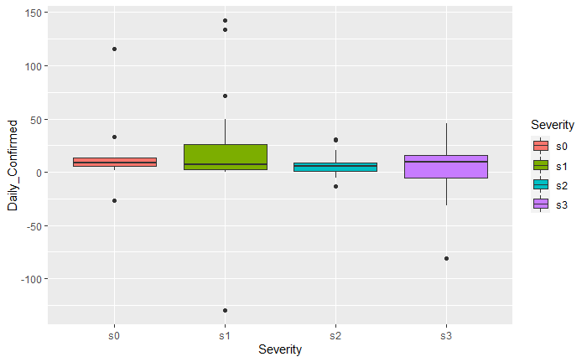

*Figure 14 - Boxplots for the spreads of severities, given a policy and COVID statistic.*

We then compile these results for every combination of policy and statistic into a spreadsheet. These results can be seen in the next section.

**6. Model Validation**

Basic idea for our result is using the model to check the P-value and remove the variable which is not significant (P-value > 0.05), and then we use the variables to get the mean slope of the statistic variable. After that we will use different policies to check when the policy comes up what kind of slope it lies. So, we can know whether the policy is good for the states or not.

As a result we put different mean slopes in the table. So we can see the slope during the policy. If it is increasing. We can make the be red color which means the policy is not that good for these states. Opposite way, we will use green to say the policy is good for states. The light green means decreasing slope a little bit and the light yellow is the opposite way for light green.

We can see the slope for each element. Daily Confirmed infection statistics is very good with Workplace.closing, Stay.at.home.requirements, and Close.public.transport policy. Confirmed infection statistics is good with Workplace.closing, Close.public.transport, and Restrictions.on.internal.movement policy. Daily Deaths infection statistics is good with Stay.at.home.requirements. Mortality_Rate infection statistics is good with Contact.tracing and Facial.Coverings policy. Hospitalization Rate infection statistics is good with School.closing, Workplace.closing, and Restrictions.on.internal.movement policy. It is a lot of benefit. However, we can see the policy rows. We compare the policy row for each other. We can see the Workplace.closing policy and Stay.at.home.requirements are very good policies because we can see they cover three columns in the table which is a very useful policy. The second good policy are Close.public.transport and Restrictions.on.internal.movement. We can check the color. There is no increasing much and has two decreasing slopes which is very good for states.

| **Format for each cell:**  Severity 0 / Severity 1 / Severity 2 / Severity 3 |  | | | | | |
| --- | --- | --- | --- | --- | --- | --- |
| **2020/04/12 - 2020/11/30** | **Daily_ Confirmed** | **Confirmed** | **Daily_Deaths** | **Deaths** | **Mortality_Rate** | **Hospitalization Rate** |
| **C1_School. closing** | 5.738792 / 28.802295 / 30.560997 / 8.267053 | 822.0345 / 1243.8096 / 1392.3540 / 738.5575 | 0.03661297 / 0.25753297 / -0.22277977 | 18.61259 / 17.78315 / 17.78195 / 18.64591 | 0.007143716 / -0.007238456 / -0.011645607 / -0.009957272 | 0.02041031 / -0.01487413 / -0.14346565 |
| **C2_Workplace. closing** | 19.432493 / 15.566366 / 5.724879 / 2.105792 | 1256.4352 / 1152.5142 / 803.5056 / 631.4263 | 0.01884353 / 0.13171595 / -0.04416844 / -0.87128391 | 17.96419 / 12.62207 / 16.39584 / 36.59920 | -0.009197771 / -0.019253122 / -0.009043462 / 0.051218430 | -0.04599359 / -0.06156813 / -0.08893090 / -0.13984666 |
| **C3_Cancel. public.events** | 9.871125 / 18.713135 / 4.322083 | 483.6236 / 1106.8513 / 848.2091 | 0.07030446 / 0.09303609 / -0.27027401 | 7.73851 / 14.13426 / 23.79544 | -0.0248885862 / -0.0141952672 / -0.0005041304 | -0.05112064 / -0.03905952 / -0.16454710 |
| **C4_Restrictions. on.gatherings** | 37.921358 / 8.992664 / 13.182561 / 11.916064 / 10.384745 | 1234.2970 / 513.7334 / 663.0043 / 909.7240 | 0.24418724 / -0.30789449 / 0.06825489 / 0.02054433 | 16.38743 / 14.00021 / 9.43436 / 12.62286 | -0.02385567 / -0.01372284 / -0.01860606 / -0.01603693 | -0.04700318 / -0.28388121 / -0.05735622 / -0.07100882 |
| **C5_Close.public.transport** | 14.04569654 / 5.69162978 / -0.08687578 | 1260.9577 / 927.7777 / 375.5397 | 0.07638495 / -0.21956821 / 0.01201718 | 18.58227 / 21.46480 / 21.40146 | -0.011525114 / -0.004935623 / 0.018791401 | -0.17620314 / -0.09302019 / -0.14136988 |
| **C6_Stay.at.home.requirements** | 26.052273 / 17.701753 / 6.322949 | 814.0256 / 1054.8345 / 879.0159 | 0.129163249 / -0.003080392 / -0.871512785 | 7.629382 / 16.459964 / 31.261815 | -0.01270839 / -0.01334612 / 0.02270115 | -0.05446706 / -0.06567605 / -0.21734244 |
| **C7_Restrictions.on.internal. movement** | 8.652963 / 4.217188 / 17.584024 | 1023.8812 / 968.4974 / 787.4026 | -0.1846761 / -0.6920701 / -0.1150139 | 21.70085 / 22.40220 / 18.63930 | -0.010561445 / -0.012465706 / 0.005925379 | -0.06854146 / -0.11242649 / -0.18833079 |
| **C8_International. travel.controls** | 11.71423 / 20.92143 / 36.74277 | 893.6702 / 1722.6144 / 1273.5739 | -0.081519585 / 0.096834590 / 0.000612547 | 17.51943 / 30.58872 / 12.61595 | -0.005805797 / -0.016457928 / -0.010238799 | -0.13493702 / -0.23345262 / -0.06915499 |
| **H3_Contact. tracing** | 12.016687 / 6.674771 / 10.705759 | 371.361 / 1001.267 / 1045.427 | -0.04141815 / -0.08878395 / 0.08698225 | 20.29258 / 46.90511 / 16.00030 | 0.05529141 / 0.01686469 / -0.01286600 | -0.08247767 / -0.14605570 / -0.04829351 |
| **H6_Facial. Coverings** | 9.698760 / 5.904986 / 14.151217 / 17.909378 | 347.6404 / 319.1075 / 934.0142 / 1295.8489 | 0.10241891 / -0.17470554 / -0.21981043 / 0.05842907 | 14.16945 / 10.67113 / 22.04613 / 19.80602 | 0.033609543 / 0.006438228 / -0.002149773 / -0.011307956 | -0.12225424 / -0.18297987 / -0.02545019 / -0.06819130 |

*Table 1 - Modeling result for policy which affect the statistic*

According to the data of C2 Workplace.Closing, we can see that the Daily_Confirmed, Confirmed and Hospitalization Rate indicators have an obvious downward trend of slope, which means that some policies adopted by C2 are all effective in suppressing the spread of virus.

From the specific policy stage, for Daily_Confirmed, when the policy changes from severity 1(15.566366) to severity 2 (5.724879), the slope decreases most obviously. That is to say, compared with other policies, severity 2 policy is the most efficient to restrain Daily_Confirmed; as for the Confirmed index, the overall downward trend of the Daily_Confirmed index also directly affects the overall Confirmed data. When the policy changes from severity 1(1152.5142) to severity 2 (803.5056), the slope decreases most obviously. In the same way as Daily_Confirmed, severity 2 policy is the most efficient for restraining Confirmed; As for Hospitalization Rate, when the policy changes from severity 2(-0.08893090) to severity 3 (-0.13984666), the slope decreases most obviously. That is to say, compared with other policies, severity 3 policy is the most efficient for restraining Hospitalization Rate. Therefore, from the overall data, although policies of severity 1, 2 and 3 all have an effective impact, the positive impact of severity 2 is the most obvious.

According to the data of C6_Stay.at.home.requirements, we can clearly see that the slope of Daily_Confirmed, Daily_Deaths and Hospitalization Rate is in a downward trend. Although the Deaths index doesn't look very good, on the whole, C6 policy has a positive impact on restraining the spread of viruses.

According to the Daily_Confirmed index, when the policy goes from none (26.052273) to severity 1 (17.701753) and then to severity 2(6.322949), the slope has an obvious downward trend, which shows that severity 1 and 2 are efficient policies for the Daily_Confirmed index; From the Daily_Deaths index, we can find that the slope decline is the most obvious from severity 1 (-0.003080392) to severity 2( -0.871512785), which shows that severity 2 policy is the most efficient for Daily_Deaths index compared with other policy stages; As for the Hospitalization Rate index, when the policy stage changes from severity 1( -0.06567605) to severity 2(-0.21734244), the slope has an obvious change, which shows that severity 2 is the most efficient policy for the Hospitalization Rate index. Above overall data, we conclude that severity 2 is the most efficient policy stage.

According to the data of C7_Restrictions.on.internal.movement, we can clearly see that the slopes of Confirmed and Hospitalization Rate are showing a downward trend, which means that the policies adopted by C7 are effective in suppressing the spread of virus.

According to the specific data, for the Confirmed index, the slope has dropped obviously from 968.4974 of severity 1 to 787.4026 of severity 2, so severity 2 has the most obvious positive influence on the Confirmed index. For Hospitalization Rate, the policy changes from severity 0(0.06854146) to severity 1(-0.11242649) and then to severity 2(-0.18833079). severity 1 and severity 2 have similar effects on Hospitalization Rate index, and they are both efficient policies.

**7. Conclusion**

Our analysis produced somewhat mixed results. Workplace closings and stay-at-home requirements were associated with noteworthy reductions across multiple categories, indicating that these policies were generally effective in combating COVID-19. Policies that imposed restrictions on internal movements also displayed some positive results in relation to the number of confirmed cases and hospitalization rates in multiple states. The closure of public transportation services was associated with positive changes in the rate of new confirmed COVID-19 infections, but did not seem to positively affect deaths or overall mortality rate. Interestingly, the cancelation of public events was actually associated with negative outcomes in terms of the death and mortality rates. Another unexpected result was with regards to the use of facial coverings, which were associated with mixed results instead of the general positive effect one may have assumed. Based on the results that we have received, we would recommend that, going into the peak of flu season, state governments mandate workplace closures along with stay-at-home requirements, internal movement restrictions, and the closure of public transportation. International travel does not appear to be associated with any positive effect on infection metrics, so it may not be advisable to restrict international flights over the holidays. Additionally, while facial coverings showed mixed results in our analysis, prior data does indicate their effectiveness, so state governments may wish to consider the implementation of an optional mask mandate such as the one implemented by Kansas [5]. While we stand by the validity of our results, we must still urge caution when using these results to make public policy decisions. As we have already mentioned, confounding factors do exist for datasets this expansive, and policies that are effective in one state may not work so well in other states depending on differing conditions. Our analysis was focused on a high-level picture of the relationship between public policies and COVID-19 statistics, individual states may wish to conduct their own analyses in the future in order to make the best choice for themselves. Moving forward into the 2020-2021 flu season, we recommend that individual states continue monitoring their infection and death rates, along with the time sensitive effects of policy implementation on those rates. More time series data is needed, and we hope that our recommendations are helpful in mitigating the impact of this disease.

**8. Source Code**

We used Google Drive for collaboration, and to store all our data / code:

<https://drive.google.com/drive/folders/1h14J3nIYZ6s1IkcsikvREHc2otgz-Azv?usp=sharing>

**9. Bibliography**

[1] R. C. Castillo, E. D. Staguhn, and E. Weston-Farber, “The effect of state-level stay-at-home orders on COVID-19 infection rates,” American Journal of Infection Control, vol. 48, no. 8, pp. 958–960, Aug. 2020, doi: 10.1016/j.ajic.2020.05.017.

[2] C. Courtemanche, J. Garuccio, A. Le, J. Pinkston, and A. Yelowitz, “Strong Social Distancing Measures In The United States Reduced The COVID-19 Growth Rate: Study evaluates the impact of social distancing measures on the growth rate of confirmed COVID-19 cases across the United States.,” Health Affairs, vol. 39, no. 7, pp. 1237–1246, Jul. 2020, doi: 10.1377/hlthaff.2020.00608.

[3] D. Dave, A. I. Friedson, K. Matsuzawa, and J. J. Sabia, “When Do Shelter-in-Place Orders Fight Covid-19 Best? Policy Heterogeneity Across States and Adoption Time,” Economic Inquiry, vol. n/a, no. n/a, doi: 10.1111/ecin.12944.

[4] M. E. V. Dyke, “Trends in County-Level COVID-19 Incidence in Counties With and Without a Mask Mandate — Kansas, June 1–August 23, 2020,” MMWR Morb Mortal Wkly Rep, vol. 69, 2020, doi: 10.15585/mmwr.mm6947e2.

[5] S. Hsiang et al., “The effect of large-scale anti-contagion policies on the COVID-19 pandemic,” Nature, vol. 584, no. 7820, Art. no. 7820, Aug. 2020, doi: 10.1038/s41586-020-2404-8.

[6] K. Luo et al., “Transmission of SARS-CoV-2 in Public Transportation Vehicles: A Case Study in Hunan Province, China,” Open Forum Infect Dis, vol. 7, no. 10, Oct. 2020, doi: 10.1093/ofid/ofaa430.

[7] C. R. MacIntyre and A. A. Chughtai, “A rapid systematic review of the efficacy of face masks and respirators against coronaviruses and other respiratory transmissible viruses for the community, healthcare workers and sick patients,” Int J Nurs Stud, vol. 108, p. 103629, Aug. 2020, doi: 10.1016/j.ijnurstu.2020.103629.

[8] K. Prem et al., “The effect of control strategies to reduce social mixing on outcomes of the COVID-19 epidemic in Wuhan, China: a modelling study,” The Lancet Public Health, vol. 5, no. 5, pp. e261–e270, May 2020, doi: 10.1016/S2468-2667(20)30073-6.

[9] E. Ziedan, K. Simon, and C. Wing, “Effects of State COVID-19 Closure Policy on NON-COVID-19 Health Care Utilization,” National Bureau of Economic Research, Cambridge, MA, w27621, Jul. 2020. doi: 10.3386/w27621.

**10. Data Sources**

[10] First dataset idea: <https://c3.ai/products/c3-ai-covid-19-data-lake/>

* Retired due to limited accessibility within the API

[11] Daily state reports: <https://github.com/CSSEGISandData/COVID-19>

[12] Initial State policies:

* Retired due to lack of data and confusing descriptions for policy “levels.”
* <https://github.com/KFFData/COVID-19-Data/tree/kff_master/State%20Policy%20Actions/State%20Social%20Distancing%20Actions>
* <https://drive.google.com/drive/u/0/folders/1a43n9eVOm4vwTpLN3DXnXB6ACxZ1xC3H>

[13] State policies: <https://github.com/OxCGRT/USA-covid-policy>

* Website: <https://www.bsg.ox.ac.uk/research/research-projects/coronavirus-government-response-tracker>
* <https://drive.google.com/drive/u/0/folders/1oJO8h18E9wrvuzp4CzhkxbLBgfGIgBct>

[14] Combined data: <https://docs.google.com/spreadsheets/d/1aY37iAZaZLEvgKDyM_nPTnp4qdqqizp4sIkxP7LY3Zo/edit#gid=1591812776>

* Link to Florida emergency order for August 1st: <https://web.archive.org/web/20200809200209/http://www.fldoe.org/core/fileparse.php/19861/urlt/DOE-2020-EO-06.pdf>